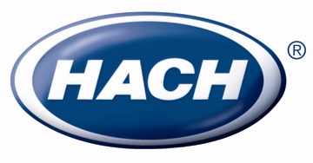

FOR IMMEDIATE RELEASE
For more information, contact:
Monique Lanphear
(970) 663-1377 x2533
mlanphea@hach.com
Hach Introduces Customer Support Portal
Portal provides software customers with online support
Loveland, Colo. – December 1, 2009 – Hach Company (www.hach.com) now offers online support for customers of the Hach Water Information Management Solution™ (Hach WIMS™) software family of products.

This web browser-based customer support portal enables customers to easily track issues because each item is assigned a unique tracking number which instantly identifies history of all communication between parties involved in issue resolution. Customers can review all communication with support personnel, upload screenshots of issues, collaborate on resolution of issues and view resolution status.
“Convenient and timely access to support information is critical to keep operations running smoothly.” Chuck Scholpp, Hach Information Management Business Unit Manger said. “The Hach customer support portal is another example of Hach providing world-class support for software, instruments and service.”

For more information on the customer support portal, please visit www.hach.com/im and click on the Helpful links section or call 1-800-677-0067.

About Hach Company
For over 60 years, Hach Company (www.hach.com) has been developing innovative solutions used to test the quality of water, other liquids and air. Manufactured and distributed worldwide, Hach systems are designed to simplify analysis by offering sophisticated on-line instrumentation, accurate portable laboratory equipment, high-quality prepared reagents, complete easy-to-follow methods, and life-time technical support. Hach is a wholly owned subsidiary of Danaher Corporation (www.danaher.com), a Fortune 500 leader.
# # #

